**Send, parse xml response and parse json, explore native logging**

Open eclipse and create a maven project

Send xml

**package** Response;

import static io.restassured.RestAssured.given;

import org.hamcrest.Matchers;

import org.testng.Assert;

import org.testng.annotations.Test;

import io.restassured.http.ContentType;

import io.restassured.response.Response;

public **class** XMLResponse

{

@Test

public void post_xml_test() {

Response response = given().contentType(ContentType.XML).accept(ContentType.XML).body("<Employee>" +

"<empName>Lavanya Gowda</empName>" + "<empAddress>abc</empAddress>"

+ "<mobileNumber>1592211560</mobileNumber>" + "<department>abc</department>" + "<project>abc</project>"

+ "<teamLead>abc</teamLead>" + "<salary>10000</salary>" + "<joiningDate>11-10-19</joiningDate>"

+ "</Employee>").when().post("http://192.168.1.207:8080/api/employee/add/xml");

System.out.println("POST Response\n" + response.asString());

// tests

int statusCode = response.getStatusCode();

System.out.println("Status code is:" + statusCode);

Assert.assertEquals(200, statusCode);

}

}

Result

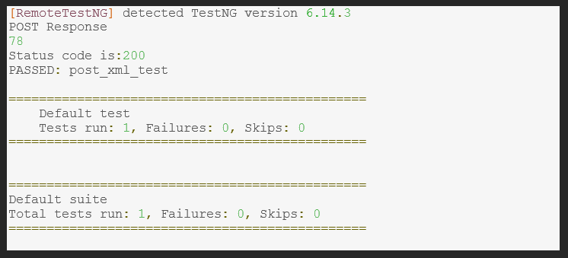

Parsing xml

**package** Response;

import org.testng.annotations.Test;

import org.testng.Assert;

import io.restassured.RestAssured;

import io.restassured.http.ContentType;

import io.restassured.response.Response;

import static io.restassured.RestAssured.*;

public **class** ParseXML

{

@Test

public void parse_xml_test() {

Response response = given().contentType(ContentType.XML).accept(ContentType.XML).body("<Employee>" +

"<empName>Lavanya Gowda</empName>" + "<empAddress>abc</empAddress>"

+ "<mobileNumber>1591111560</mobileNumber>" + "<department>abc</department>" + "<project>abc</project>"

+ "<teamLead>abc</teamLead>" + "<salary>10000</salary>" + "<joiningDate>11-10-19</joiningDate>"

+ "</Employee>").when().post("http://192.168.1.207:8080/api/employee/add/xml");

System.out.println("POST Response\n" + response.asString());

// tests

int statusCode = response.getStatusCode();

System.out.println("Status code is:" + statusCode);

Assert.assertEquals(200, statusCode);

}

}

Result

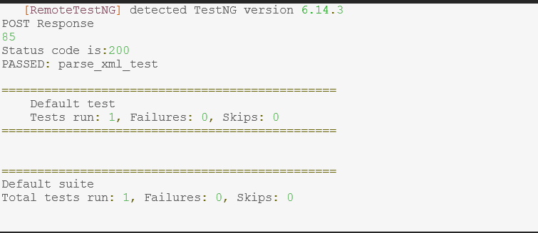

Parsing xml

**package** Response;

import org.testng.annotations.Test;

import org.testng.Assert;

import io.restassured.RestAssured;

import io.restassured.http.ContentType;

import io.restassured.response.Response;

import static io.restassured.RestAssured.*;

public **class** ParseXML

{

@Test

public void parse_xml_test() {

Response response = given().contentType(ContentType.XML).accept(ContentType.XML).body("<Employee>" +

"<empName>Lavanya Gowda</empName>" + "<empAddress>abc</empAddress>"

+ "<mobileNumber>1591111560</mobileNumber>" + "<department>abc</department>" + "<project>abc</project>"

+ "<teamLead>abc</teamLead>" + "<salary>10000</salary>" + "<joiningDate>11-10-19</joiningDate>"

+ "</Employee>").when().post("http://192.168.1.207:8080/api/employee/add/xml");

System.out.println("POST Response\n" + response.asString());

// tests

int statusCode = response.getStatusCode();

System.out.println("Status code is:" + statusCode);

Assert.assertEquals(200, statusCode);

}

Result

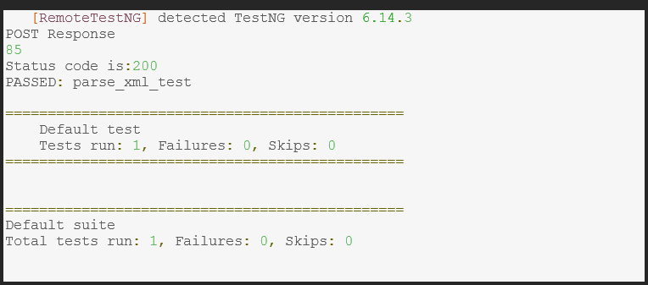

Parsing json

**package** Response;

import static org.testng.Assert.assertEquals;

import java.util.List;

import org.json.simple.JSONObject;

import org.testng.annotations.Test;

import io.restassured.RestAssured;

import io.restassured.http.Method;

import io.restassured.path.json.JsonPath;

import io.restassured.response.Response;

import io.restassured.specification.RequestSpecification;

import junit.framework.Assert;

public **class** JsonParse {

    @Test

    public void testJsonParsing() {

        //specify base URI

RestAssured.baseURI="http://192.168.1.207:8080/api/employee/";

//Request object

RequestSpecification httpRequest=RestAssured.given();

//contains the information in the json format

//Request payload sending along with post request

JSONObject requestParams=new JSONObject();

requestParams.put("empName","Lavanya");

requestParams.put("empAddress","Bomanahalli");

requestParams.put("mobileNumber","9109320002");

requestParams.put("department","testing");

requestParams.put("teamLead","Aruna");

requestParams.put("salary","10000");

requestParams.put("joiningDate","14-05-19");

httpRequest.header("Content-Type", "application/json");

httpRequest.body(requestParams.toJSONString());//attach above data to the request

//Response object

Response response=httpRequest.request(Method.POST,"/add");

//print response in console window

String responseBody=response.getBody().asString();

System.out.println("Response Body is:" +responseBody);

//status code validation

int statusCode=response.getStatusCode();

System.out.println("Status code is:" +statusCode);

Assert.assertEquals(200,statusCode);

Result

